Triumph Scrambler Xe Xc Tail Tidy Installation Instructions.

- Remove Seat.
- Remove inner plastic tray held in with three screws. The front two have no nut on them. The rear one has a stepped washer on it.
- Lift up and set aside. You don’t need to unplug the 2 cables.
- Under the seat is a while connector for the rear lights. Unplug.
- Under the mud guard there are two bolts near the rear shocks. Undo these. They may be very tight with thread lock.
- Now around the seat lock are 4 bolts with a torx drive. Loosen bolts. With these removed the mud guard will fall off. There are 4 top hat washers between the mudguard and bike frame. Don’t lose them.
- You can now work on the tail in isolation.
- Remove the bolts securing the arch liner from the metal mug guard.
- Now you will need to strip out the indicators and taillight if you are reusing it.
- You will now need to cut the arch liner just next to the rebated holes for bolting it on as per the picture. (if you ever need to put your bike back to factory standard these liners are available for around £70 from Triumph. A good hacksaw and a file make easy work of this. Some fettling at the sides of the plastic liner may be required if you are using the indicator bracket.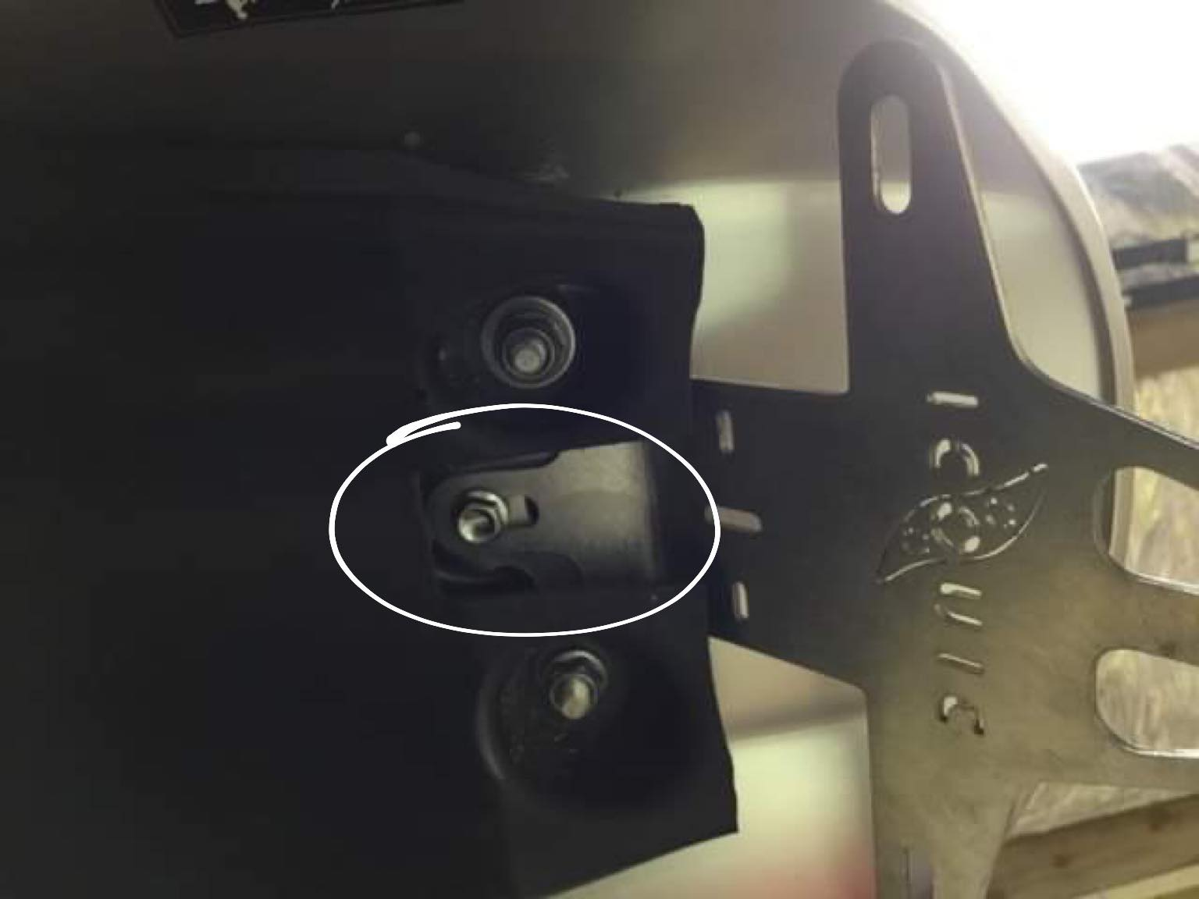
- Fit lights to tail tidy as required and secure cables loosely
- Put tail tidy over the two studs on the metal mud guard. Fit the two plastic spacers between the tail tidy and the guard. If you are using the indicator bracket fit this also.
- Put in central 6mm screw then tighten and use plastic spacer between the tail tidy and the guard. (see point 10)
- Route light loom and secure in please.
- Lay on plastic arc liner and refit screw in reverse order to what you removed them.
- Fit arch to bike.
- Don’t forget to connect your white light plug.
- Refit the plastic tray and all you have left to do is hang a number plate off the bracket.